EVENT REMINDER APP
@CREATIVITY THINK (9483175986/7019689991)

ABSTRACT:
The Event Reminder App is a web-based platform designed to simplify event creation, scheduling, and reminders for individuals, businesses, and community groups. Users can register, create events, sync with calendars, schedule reminders, and monitor upcoming activities through an interactive dashboard. Administrators oversee user activity, manage events, send mass notifications, and review analytics to ensure seamless event coordination. Built using Django and Django Rest Framework for the backend and React with React-Calendar for the frontend, the system enhances productivity and organization by providing automated reminders and centralized event management..

INTRODUCTION OF THE PROJECT:
Managing multiple personal, professional, or community events often leads to missed appointments and poor coordination. The Event Reminder App provides a structured platform where users can create events, customize reminders, and sync schedules with their calendar applications. Administrators manage the overall event structure, review statistics, and send mass notifications for large groups. With Django powering backend operations and React ensuring an interactive frontend experience, the system offers reliable scheduling, real-time updates, and user-friendly dashboards. This platform improves organizational efficiency and supports individuals and groups in staying updated with important dates..

PROJECT OBJECTIVES:

• To create a centralized platform for event scheduling and reminders
• To provide users with calendar synchronization features
• To enable timely notification delivery for upcoming events
• To offer dashboards for tracking future and past events
• To allow administrators to manage events and users efficiently
• To provide mass communication tools for communities and organizations
• To generate event statistics for admin review

PROBLEM OF THE STATEMENT:
Individuals and groups often struggle to manage multiple events, leading to missed deadlines, forgotten appointments, and inefficient communication. Existing tools may lack centralized dashboards, automated reminders, or admin-level control for group event management. The Event Reminder App addresses these challenges by offering a unified platform that enables users to create events, sync calendars, schedule reminders, and receive timely notifications while administrators manage users, send announcements, and analyze event data. This system enhances clarity, communication, and event coordination for both personal and group use..

MOTIVATION OF THE PROJECT:
• Increasing need for automated event reminders
• Growing reliance on digital calendars for work and social activities
• Lack of centralized platforms for group reminder management
• Need for mass notifications in community or business settings
• Improved efficiency through automated scheduling systems

BLOCK DAIGRAM OF PROJECT:

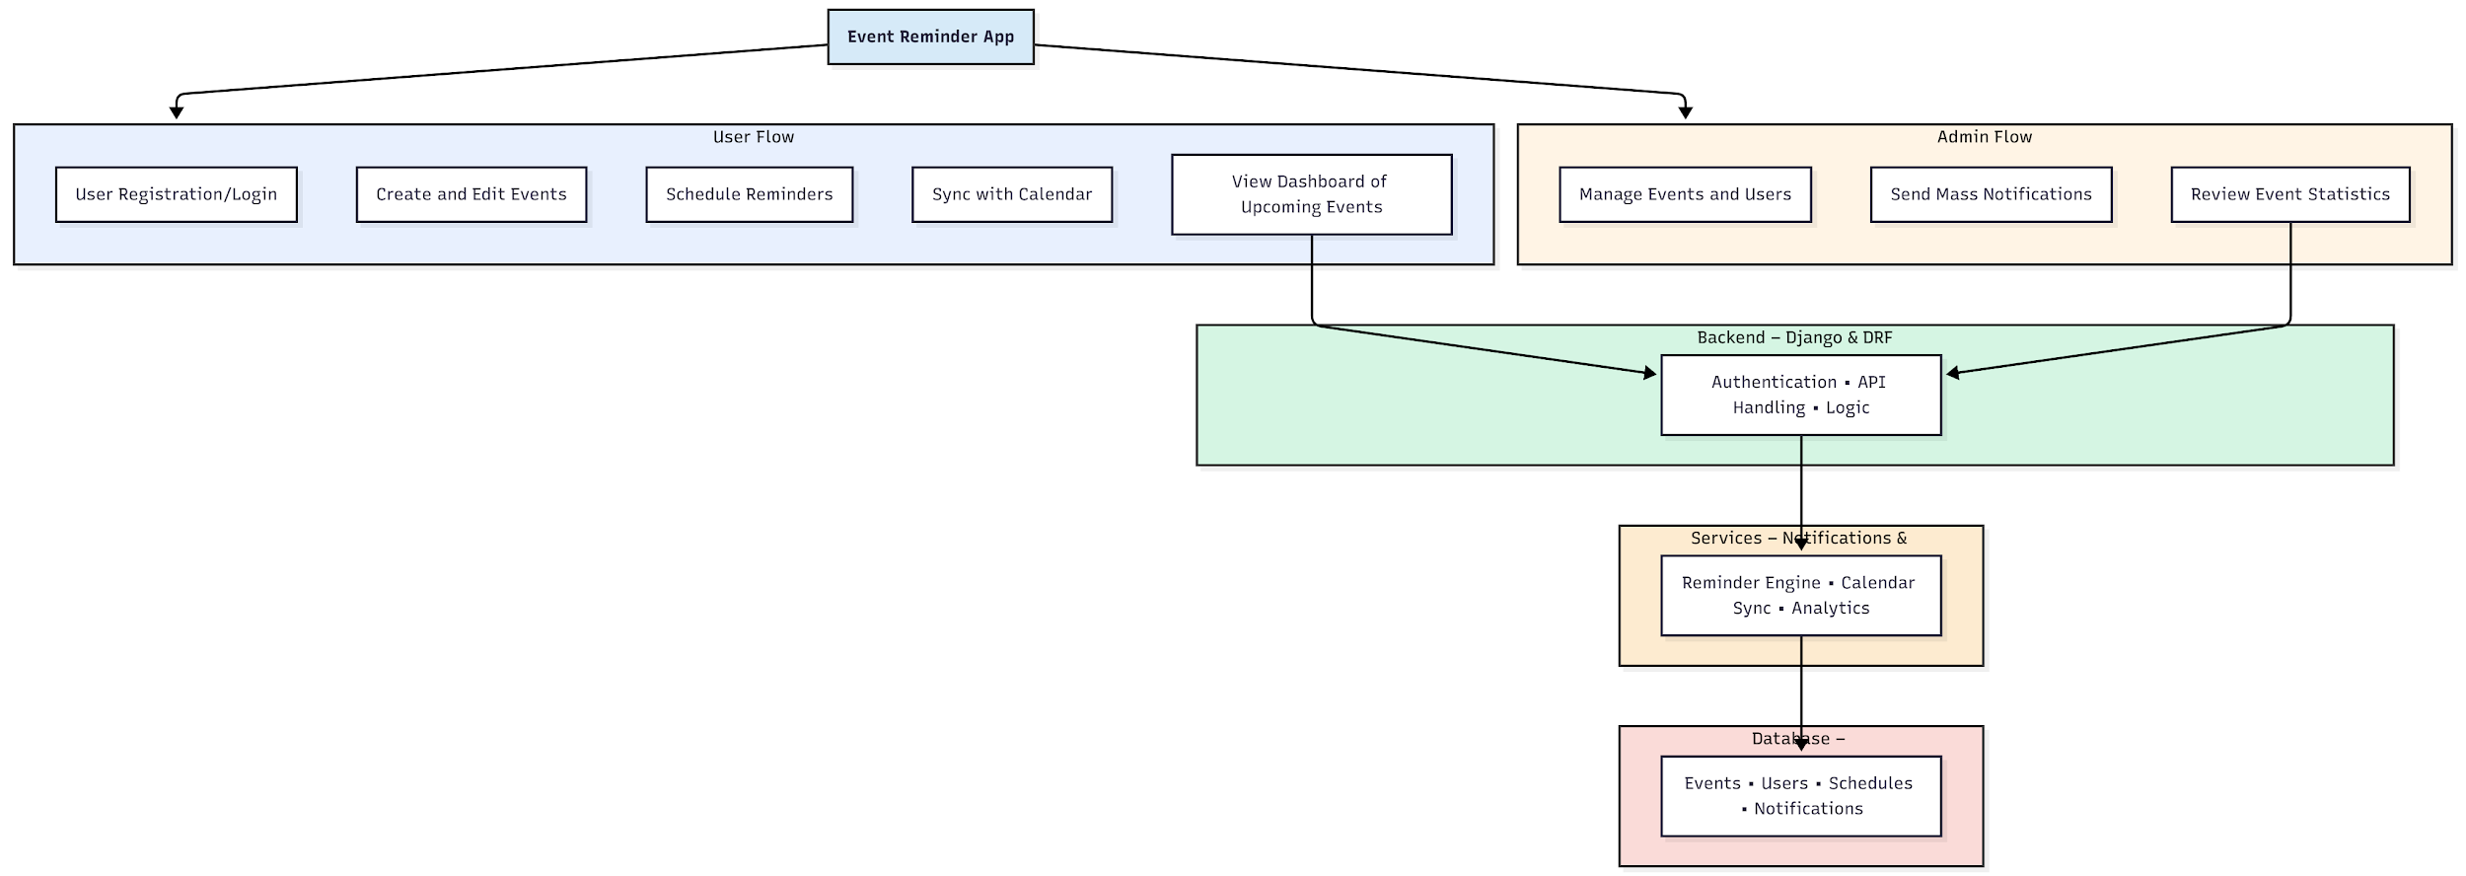

WORKING OF THE PROJECT:
Users register or log in and begin creating events with scheduled reminder times, syncing them with their calendars for seamless organization. They can access an interactive dashboard that displays upcoming events and notifications. The backend handles authentication, event data processing, and communication with the notification services. The system’s reminder engine automatically triggers messages before events occur. Administrators manage users, update or remove events, send mass notifications for large groups, and review event activity statistics. This coordinated workflow ensures timely reminders, efficient event organization, and smooth communication..

SOFTWARE REQUIREMENT:
- Backend:
  - Python 3.x
  - Django
  - Django REST Framework
  - SQLite/PostgreSQL
- Frontend:
  - Node.js and npm
  - React.js
  - Axios
- Development Tools:
  - Visual Studio Code
  - Postman (for testing APIs)
  - Git/GitHub (for version control)
- Server/Deployment (Optional):
  - Gunicorn, Nginx, or Heroku/AWS for hosting

ADVANTAGES OF THE PROJECT:

• Ensures timely reminders for all scheduled events
• Supports calendar syncing for improved organization
• Centralized dashboard for tracking upcoming activities
• Admin capabilities for mass messaging and analytics
• Reduces missed events and enhances productivity
• Useful for both individuals and community groups
• Secure, reliable, and scalable system
• User-friendly interface with real-time updates

APPLICATIONS OF THE PROJECT:
• Personal event and reminder management
• Office meeting and task scheduling
• Community event coordination
• School or college reminders for deadlines
• Business appointment tracking
• Social group event planning
• Religious or cultural event reminders
• Clubs, societies, and organization announcements

REFERENCES:

- Django REST Framework Documentation — Django Software Foundation. Django Documentation. Available: https://docs.djangoproject.com/
- Django REST Framework. DRF Documentation. Available: https://www.django-rest-framework.org/
- React. React Official Documentation. Available: https://reactjs.org/docs/getting-started.html
- Redux. Redux Documentation. Available: https://redux.js.org/introduction/getting-started
- PostgreSQL Global Development Group. PostgreSQL Documentation. Available: https://www.postgresql.org/docs/
- MySQL. MySQL Reference Manual. Available: https://dev.mysql.com/doc/
- Git. Git Documentation. Available: https://git-scm.com/doc
- Node.js. Node.js Documentation. Available: https://nodejs.org/en/docs/
- Axios. Axios Documentation. Available: https://axios-http.com/docs/intro
- Socket.io Documentation – https://socket.io/docs/

